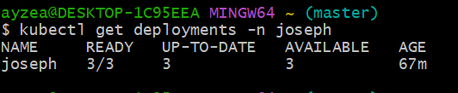

Describe Deployment:  
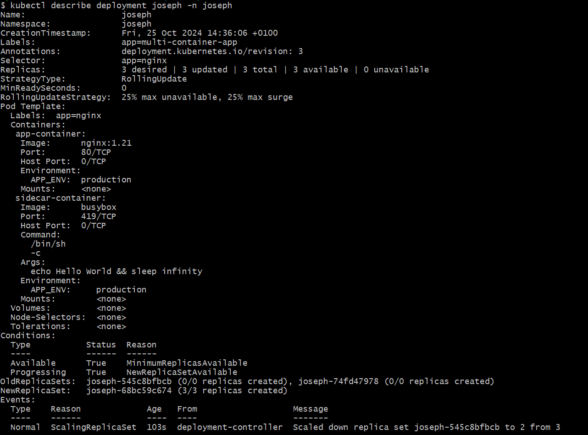 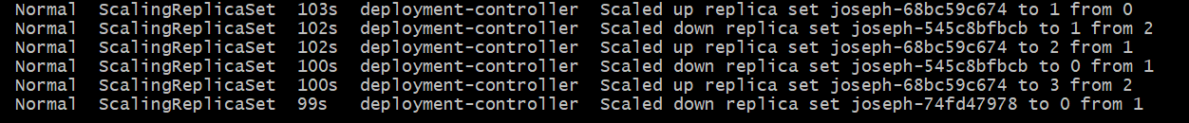

Get pods  
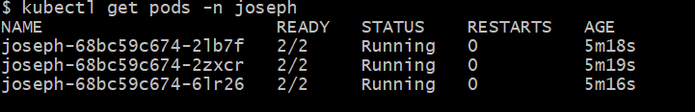

To Create Service to expose the Deployment;

